Real-Time Gesture-Based Drone Control with Safety-Aware Command Filtering

Abstract
Gesture-based control offers an intuitive alternative to traditional remote controllers for unmanned aerial vehicles (UAVs), but its reliability and safety in real-time operation remain significant challenges. This paper presents a real-time hand-gesture control system for drone operation, integrating vision-based gesture recognition, command stabilization, and safety-aware filtering into a unified pipeline. The system uses a client-side gesture inference module combined with a REST-based control interface to issue commands to either a physical drone or a simulator.
To address instability in raw gesture predictions, a stabilization layer is introduced using confidence thresholds, temporal consistency, and cooldown mechanisms. In addition, a safety layer filters commands based on gesture behavior types, reducing unintended or unsafe drone actions. A comprehensive evaluation framework is implemented to measure system performance across multiple dimensions, including prediction accuracy, latency, command safety, and robustness under varying environmental conditions.
Experimental results demonstrate that stabilized gesture recognition significantly improves accuracy compared to raw predictions, while the safety layer effectively reduces false command execution. The findings suggest that gesture-based drone control is feasible for real-time applications when combined with appropriate filtering and safety mechanisms, though limitations remain in handling environmental variability and gesture ambiguity.

1. Introduction
Unmanned aerial vehicles (UAVs), commonly referred to as drones, are increasingly used in applications such as surveillance, inspection, and entertainment. Despite their growing popularity, controlling drones remains a complex task that typically requires specialized remote controllers or mobile interfaces. These traditional control methods introduce a learning curve and can limit accessibility for novice users.
Gesture-based control has emerged as a promising alternative, offering a more natural and intuitive interaction paradigm. By leveraging computer vision techniques, users can issue commands through hand movements without the need for physical controllers. However, this approach introduces new challenges, particularly in achieving reliable gesture recognition and ensuring safe operation in real time. Variability in lighting conditions, background complexity, and user behavior can significantly impact recognition accuracy, while misinterpreted gestures may lead to unintended or unsafe drone actions.
This paper investigates whether hand-gesture control can be both reliable and safe for real-time drone operation. To address this problem, we design and implement a full-stack gesture control system that integrates gesture detection, stabilization, command mapping, and safety filtering. The system operates in real time, processing video input from a camera, inferring gestures on the client side, and dispatching commands through an API to a drone or simulator.
The key contributions of this work are as follows:
- A real-time gesture-based drone control pipeline with client-side inference and API-driven command execution.
- A stabilization mechanism that improves gesture reliability using confidence thresholds and temporal consistency.
- A safety-aware command filtering system that prevents unintended or unsafe actions.
- A comprehensive evaluation framework that measures accuracy, latency, safety, and robustness under different conditions.
The remainder of this paper is organized as follows: Section 2 describes the system architecture, Section 3 explains the gesture recognition and control logic, Section 4 details the safety mechanisms, Section 5 outlines the experimental setup, Section 6 presents the results, and Sections 7 and 8 discuss the findings and conclude the paper.

2. System Architecture
The proposed system is designed as a real-time pipeline that transforms visual hand gestures into drone control commands. The architecture follows a modular approach, separating gesture inference, control logic, and command execution to ensure scalability and maintainability.
Figure 1 illustrates the overall architecture of the proposed real-time gesture-based drone control system, showing the flow from video capture to gesture interpretation, safety filtering, and final command execution.
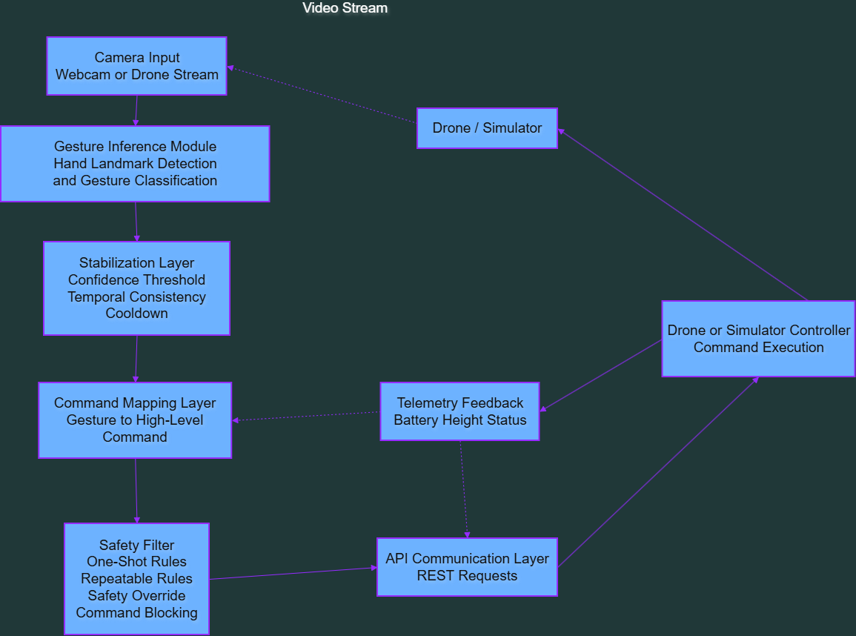
As shown in Figure 1, the system separates perception, decision-making, and execution into modular components, allowing the gesture recognition, safety logic, and backend controller to operate as loosely coupled parts of the overall pipeline.
At a high level, the system consists of the following components:
- Video Input Layer: Captures live video from either a webcam (simulation mode) or a drone camera stream. In drone mode, video is streamed using an MJPEG endpoint, while simulation mode relies on a local camera device.
- Gesture Inference Module: Processes incoming video frames to detect and classify hand gestures. This module operates on the client side and uses a vision-based approach to extract hand landmarks and infer gesture labels. Each prediction includes a confidence score and is produced at a controlled frame rate to balance performance and responsiveness.
- Stabilization Layer: Raw gesture predictions are inherently noisy in real-time environments. To address this, a stabilization mechanism aggregates predictions over time, enforcing consistency through temporal windows and confidence thresholds. Only gestures that remain stable for a minimum duration are considered valid for command generation.
- Command Mapping Layer: Stabilized gestures are translated into high-level drone commands. Each gesture is associated with a predefined action, such as takeoff, landing, directional movement, or rotation. This mapping abstracts low-level control details and ensures a consistent interface between gesture recognition and command execution.
- Safety Filter: Before commands are dispatched, they pass through a safety layer that enforces behavioral constraints. This includes cooldown intervals, gesture-type restrictions (e.g., one-shot vs. repeatable commands), and emergency overrides. Commands that violate safety conditions are blocked and logged for analysis.
- API Communication Layer: Valid commands are sent to a backend controller via a REST API. The backend manages the drone or simulation environment and executes commands accordingly. This separation allows the system to support both physical drones and simulated environments without modifying the client-side logic.
- Drone/Simulator Controller: The backend component interfaces directly with the drone hardware or a simulation engine. It receives commands from the API and translates them into low-level control signals, while also providing telemetry data such as battery level and altitude.
The overall data flow can be summarized as:
Camera Input → Gesture Inference → Stabilization → Command Mapping → Safety Filter → API → Drone/Simulator
This architecture enables real-time interaction while maintaining clear boundaries between perception, decision-making, and execution. By decoupling these components, the system can be extended or modified—such as replacing the gesture recognition module with a machine learning model—without impacting the rest of the pipeline.

3. Gesture Recognition and Control Logic
The gesture recognition system is designed to operate in real time using a vision-based, rule-driven approach. Instead of relying on a trained machine learning classifier, the system uses hand landmark detection combined with deterministic rules to classify gestures. This design choice prioritizes low latency and interpretability, which are critical for real-time drone control.
The system uses a hand tracking model to extract key landmark points from each video frame. These landmarks represent the positions of fingers and joints, enabling the system to infer hand posture. Based on the spatial relationships between these landmarks, gestures are classified into a predefined set, including actions such as open palm, fist, thumbs up, and directional pointing.
Each frame produces a raw gesture prediction along with a confidence score. However, real-time predictions are often unstable due to noise, motion blur, or environmental factors. To address this, the system introduces a stabilization mechanism that filters out inconsistent predictions before they are used for control.
The stabilization process is based on three main factors:
- Confidence Thresholding: Each gesture prediction must exceed a minimum confidence level to be considered valid. Low-confidence predictions are discarded to reduce false detections.
- Temporal Consistency: A gesture must remain consistent over a defined time window before being accepted as stable. This prevents rapid fluctuations between different gesture labels from triggering unintended commands.
- Cooldown Mechanism: After a command is triggered, a cooldown period is enforced before the same gesture can generate another command. This is particularly important for preventing repeated or accidental actions in quick succession.
Once a gesture is stabilized, it is passed to the control logic layer, where it is mapped to a corresponding drone command. The system supports different categories of gesture behaviors:
- One-shot Commands: Actions that should only be executed once per gesture occurrence, such as takeoff or landing. These require a release condition before they can be triggered again.
- Repeatable Commands: Continuous actions such as forward or lateral movement. These can be triggered repeatedly but are regulated by cooldown intervals to prevent excessive command frequency.
- Safety Commands: High-priority actions, such as an immediate stop or hover, which override other behaviors and are executed with minimal delay.
This structured approach to gesture interpretation ensures that command generation is both responsive and controlled. By combining rule-based classification with temporal stabilization and behavior-aware execution, the system achieves a balance between usability and reliability in real-time operation.
4. Safety Mechanisms
Ensuring safe operation is a critical requirement for any real-time drone control system, particularly when commands are derived from potentially noisy gesture inputs. Without proper safeguards, misclassified or unstable gestures can lead to unintended drone movements, posing risks to both the user and the environment. To address this, the system incorporates a dedicated safety layer that filters and regulates command execution.
The safety system operates between the gesture interpretation stage and the command dispatch stage, acting as a gatekeeper that determines whether a command should be executed, delayed, or blocked. This layer enforces multiple constraints designed to minimize false activations and maintain controlled drone behavior.
One key component of the safety system is the command cooldown mechanism. After a command is executed, a minimum time interval must pass before the same command can be triggered again. This prevents rapid repeated execution caused by sustained or jittery gestures, particularly for movement-related actions.
Another important feature is the distinction between gesture behavior types, which define how different commands should be handled:
- One-shot commands (e.g., takeoff, land) are executed only once per gesture occurrence. These commands require a release condition—such as a change in gesture—before they can be triggered again. This prevents repeated execution while the gesture is held.
- Repeatable commands (e.g., forward, left, right movement) can be issued multiple times but are regulated by cooldown intervals. This ensures smooth and controlled motion rather than erratic or overly frequent command bursts.
- Safety commands (e.g., stop or hover) are treated with the highest priority. These commands override other behaviors and are executed immediately when detected, providing a rapid response mechanism in case of instability or user intent to halt the drone.

Figure 2 illustrates the decision-making process of the safety layer, showing how gesture inputs are evaluated and either executed or blocked based on system state, gesture validity, and behavior constraints.
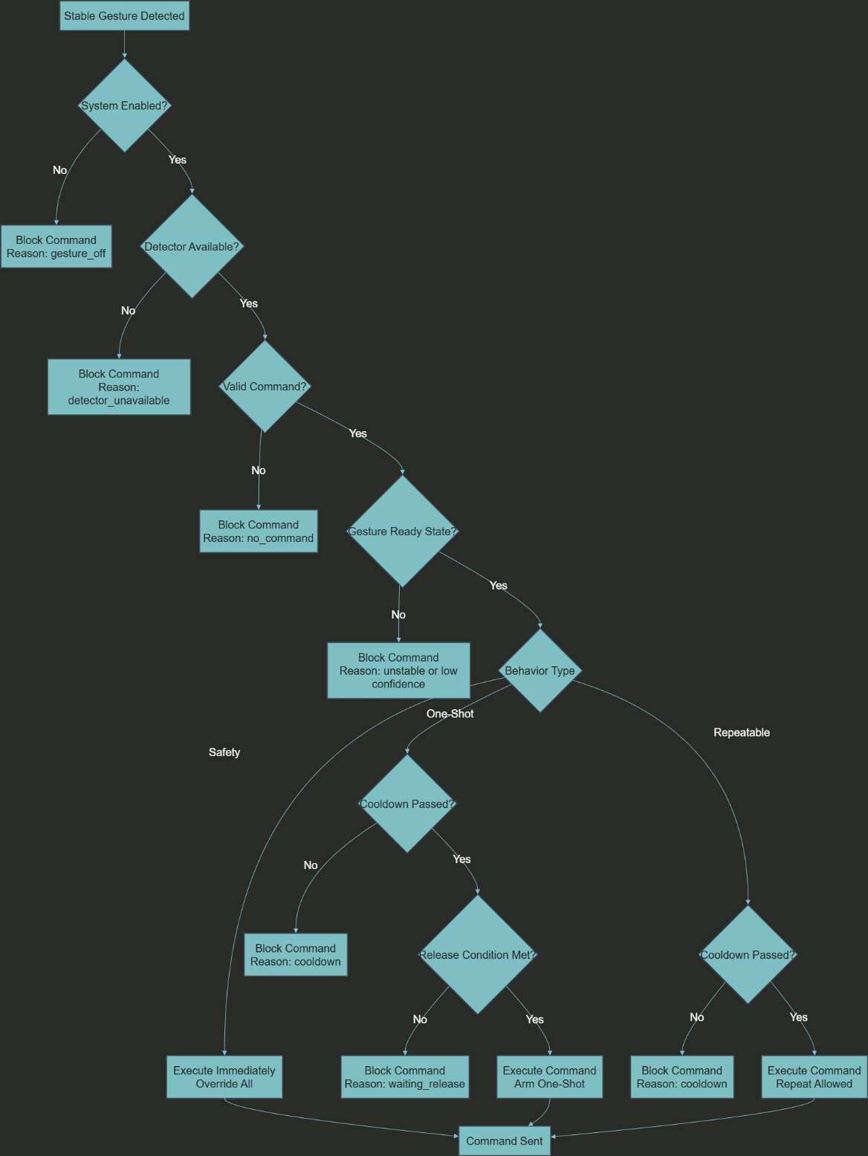
As shown in Figure 2, commands are only executed when all safety conditions are satisfied. Otherwise, they are explicitly blocked with a corresponding reason, enabling both safe operation and detailed post-analysis of system behavior.

The system also implements a command blocking mechanism, where commands are rejected if certain conditions are not met. Each blocked command is associated with a specific reason, such as insufficient gesture stability, low confidence, cooldown enforcement, or system state restrictions. These reasons are logged for later analysis, enabling detailed evaluation of system behavior and failure cases.
In addition, the safety layer ensures that commands are only dispatched when the gesture recognition system is in a valid state. For example, commands are suppressed if no hand is detected, if the gesture is not recognized, or if the system is explicitly disabled. This prevents undefined or unintended actions from being executed.
By combining cooldown control, behavior-aware execution, priority handling, and explicit command blocking, the safety system significantly reduces the likelihood of false or unsafe drone actions. This layer plays a crucial role in transforming a raw gesture recognition system into a reliable real-time control interface.

5. Experimental Setup
To evaluate the performance of the proposed gesture-based drone control system, a series of experiments were conducted under controlled conditions. The goal of the evaluation is to measure the system’s reliability, responsiveness, and safety across different environments and usage scenarios.
The system was tested using a standard webcam for gesture input in simulation mode, as well as a live video stream when connected to a drone. All gesture inference was performed on the client side, while command execution was handled through a REST-based API connected to a controller module.
Participants and Data Collection
Gesture data was collected from multiple test runs involving a single primary user performing a predefined set of gestures. Each run consisted of repeated executions of gestures such as open palm, fist, thumbs up, and directional pointing. For each frame, the system recorded both the ground truth gesture (manually labeled or predefined) and the predicted gesture, along with additional metadata.
The logging system captured detailed information for each event, including:
- Gesture predictions (raw and stabilized)
- Confidence scores
- Command execution status (dispatched or blocked)
- Timing information for latency measurement
- Environmental context (lighting, background, distance)
Environmental Conditions
To evaluate robustness, experiments were conducted under varying conditions:
- Lighting: Normal indoor lighting and reduced (low-light) conditions
- Background: Clean background (minimal visual noise) and cluttered background (multiple objects or textures)
- Distance: Different distances between the user and the camera, typically ranging from approximately 0.5 meters to 1.5 meters
These variations were introduced to simulate realistic usage scenarios and to test the system’s sensitivity to environmental changes.
Evaluation Metrics
The system was evaluated using multiple performance metrics:
- Accuracy: Measured as the proportion of correctly classified gestures, comparing both raw predictions and stabilized outputs against ground truth labels
- Latency: Measured at two levels:
  - API latency: time between command issuance and acknowledgment
  - End-to-end latency: time from gesture detection to command execution
- Safety Metrics:
  - Command dispatch rate
  - Blocked command rate
  - False command rate (incorrect commands issued relative to expected behavior)
- Robustness: Performance variations across different lighting, background, and distance conditions
All metrics were computed using a dedicated analysis pipeline that processes logged data and generates summary statistics, including confusion matrices and aggregated performance reports.
This experimental setup enables a comprehensive evaluation of the system’s behavior in real-time conditions, providing quantitative insights into both its strengths and limitations.

6. Results
This section presents the performance of the gesture-based drone control system across accuracy, latency, safety, and robustness metrics. All results are derived from logged experimental data and computed using the system’s evaluation pipeline.

6.1 Gesture Recognition Accuracy
Gesture recognition performance was evaluated by comparing both raw predictions and stabilized outputs against ground truth labels. The results show a clear improvement in accuracy after applying the stabilization layer.
- Raw Prediction Accuracy: [INSERT VALUE]
- Stabilized Gesture Accuracy: [INSERT VALUE]
The stabilization process significantly reduces noise and eliminates transient misclassifications. This confirms that temporal consistency and confidence filtering are effective in improving real-time gesture reliability.
A confusion matrix was generated to analyze misclassification patterns across gesture categories. The results indicate that most errors occur between visually similar gestures, particularly under low-confidence conditions.
Figure 1: Confusion Matrix of Stabilized Gesture Predictions

6.2 Latency Analysis
System responsiveness was evaluated using both API-level and end-to-end latency measurements.
- Average API Latency: [INSERT VALUE] ms
- Median API Latency: [INSERT VALUE] ms
- Average End-to-End Latency: [INSERT VALUE] ms
- Median End-to-End Latency: [INSERT VALUE] ms
The results show that the system maintains real-time performance, with latency remaining within acceptable bounds for interactive drone control. Minor delays were observed during periods of high gesture variability or when processing unstable frames.

6.3 Safety Performance
The effectiveness of the safety layer was evaluated by analyzing command dispatch and blocking behavior.
- Command Dispatch Rate: [INSERT VALUE]
- Blocked Command Rate: [INSERT VALUE]
- False Command Rate: [INSERT VALUE]
The safety system successfully prevented a significant portion of potentially unsafe or unintended commands. Most blocked commands were associated with unstable gestures, cooldown enforcement, or low-confidence predictions.
These results demonstrate that the safety layer plays a critical role in maintaining controlled and predictable system behavior, especially in noisy real-time environments.

6.4 Robustness Across Conditions
System performance was further analyzed under varying environmental conditions, including lighting, background complexity, and user distance.
- Lighting Conditions: Accuracy decreased under low-light conditions due to reduced visibility of hand landmarks.
- Background Complexity: Cluttered backgrounds introduced additional noise, slightly increasing misclassification rates.
- Distance Variation: Performance degraded as the distance between the user and the camera increased, affecting gesture clarity and detection confidence.
Despite these challenges, the stabilization and safety mechanisms helped maintain consistent performance across most conditions.

Overall, the results demonstrate that while raw gesture recognition alone is insufficient for reliable control, the combination of stabilization and safety filtering enables practical real-time operation. The system achieves a balance between responsiveness and accuracy, with safety mechanisms effectively reducing the risk of unintended drone actions.

7. Discussion
The results demonstrate that gesture-based drone control is feasible in real-time settings when supported by stabilization and safety mechanisms. While raw gesture predictions alone are too unstable for direct control, the introduction of temporal filtering and behavior-aware command handling significantly improves system reliability.
One of the key observations is the tradeoff between responsiveness and stability. Increasing the stabilization window and confidence thresholds reduces false positives but introduces slight delays in command execution. Conversely, reducing these constraints improves responsiveness but increases the likelihood of unintended actions. The current system achieves a balanced configuration, but the optimal parameters may vary depending on the application context.
The safety layer proved to be essential in mitigating risks associated with gesture misclassification. By enforcing cooldown intervals, requiring release conditions for one-shot commands, and prioritizing safety gestures, the system effectively prevents repeated or unsafe command execution. The relatively low false command rate indicates that these mechanisms successfully filter out most unintended actions.
However, several limitations were observed. First, the reliance on a rule-based gesture classification approach restricts the system’s ability to generalize across different users and environments. Variations in hand shape, motion speed, and positioning can affect detection accuracy. Second, environmental factors such as poor lighting and cluttered backgrounds introduce noise that impacts both confidence scores and classification stability. Third, the system was evaluated with a limited number of participants, which may not fully capture variability in real-world usage.
Another limitation is the dependency on a single camera perspective. Depth ambiguity and occlusion can lead to inconsistent gesture interpretation, particularly for complex or partially visible hand poses. Additionally, the current implementation does not incorporate adaptive mechanisms to adjust thresholds dynamically based on environmental conditions.
Despite these limitations, the system provides a strong foundation for gesture-based control. The modular architecture allows for future improvements, such as integrating machine learning models for gesture recognition or incorporating additional sensors for more robust perception.
Overall, the findings highlight that gesture-based drone control is not inherently unreliable, but requires careful system design to handle uncertainty and ensure safe operation. The combination of stabilization, safety filtering, and structured evaluation is key to making such systems practical.
8. Conclusion and Future Work
This paper presented a real-time gesture-based control system for drone operation, focusing on the challenges of reliability and safety. The system integrates vision-based gesture recognition, temporal stabilization, and a safety-aware command filtering mechanism into a unified pipeline. Through experimental evaluation, it was shown that raw gesture predictions alone are insufficient for stable control, but can be significantly improved through consistency filtering and confidence-based validation.
The results demonstrate that the combination of stabilization and safety mechanisms enables practical real-time interaction, reducing false command execution and maintaining acceptable latency. The system achieves a balance between responsiveness and control, highlighting that gesture-based interfaces can be viable alternatives to traditional input methods when properly constrained.
However, the system also reveals limitations related to environmental sensitivity, gesture ambiguity, and reliance on rule-based classification. Performance degradation under low-light conditions, cluttered backgrounds, and increased distance indicates that the current approach lacks robustness in more challenging scenarios. Additionally, the limited scope of testing suggests that further validation is required to generalize the findings.
Future work will focus on improving both the accuracy and adaptability of the system. One direction is the integration of machine learning-based gesture classifiers to replace or augment the current rule-based approach. Another area is the development of adaptive thresholding mechanisms that adjust dynamically based on environmental conditions and user behavior. Expanding the dataset to include a wider range of users and scenarios will also provide more comprehensive evaluation results.
Further enhancements may include multi-camera setups for improved depth perception, sensor fusion techniques, and more advanced control strategies for smoother drone movement. Additionally, optimizing the system for lower latency and higher frame rates could further enhance responsiveness in real-time applications.
In conclusion, while gesture-based drone control presents inherent challenges, this work demonstrates that with proper system design and safety considerations, it is a feasible and promising approach for intuitive human-drone interaction.

